
Europass diploma supplement 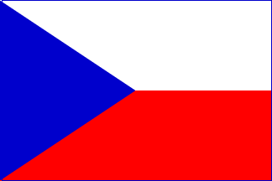
CZECH REPUBLIC
of the tertiary technical school graduate



LOGO VOŠ

 | 1. Information identifying the holder of the qualification
 | Last name/s |  |  |  |  | First name/s
1.1 |  |  |  |  | 1.2
 | Date of birth (dd/mm/yyyy) |  |  |  |  | Student identification number / code (if available)
1.3 |  |  |  |  | 1.4
 | 2. Information identifying the qualification
 | Awarded degree and conferred title (if applicable) |  |  |  |  | Main field/s of study for the qualification
2.1 | Diploma specialist – DiS. |  |  |  | 2.2 | 41-31-N/01 Regional politics of agriculture and province
 | Name and status of awarding institution (in original language) |  |  |  |  | Name of institution providing the study course(if different from 2.3, in original language)
2.3 | Masarykova střední škola zemědělská a Vyšší odborná škola, Opava, příspěvková organizace  Public school |  |  |  | 2.4
 | Language/s of instruction and examination
2.5 | Czech language
 | - Information on the level of the qualific ation
 | Level of education |  |  |  |  | Official length of programme
3.1 | Tertiary technical – ISCED 5B |  |  |  | 3.2 | 3 years of study
 | Access requirements
3.3 | Secondary education with maturita examination - ISCED 3A, ISCED 3B, fulfilling the conditions of an entry examination, health conditions
 | - Information on the contents and results gained
 | Mode of study
4.1 | Internal day study
 | Programme requirements
4.2 | Theoretical teaching: 82 weeks...............Practical teaching: 12 weeks  Absolutorium (leaving certificate): examination in a foreign language, technical examination in subjects – economy, landscape maintenance, law, defence of a graduate´s thesis

 | Programme details and the individual grades / credits obtained
4.3
 | Module / subject code |  | Module / subject title |  | Required  assessment |  | Grade |  | Date |  | Number of  ECTS credits
 | period |  | period |  | period |  | period |  | period |  | period
 | winter | summer | winter | summer | winter | summer | winter | summer | winter | summer | winter | summer
 | 1. year
 | PO101 | PO201 | English language | English language | ZKO | ZAP |  |  |  |  | 4 | 2
 | PO102 | PO202 | German language | German language | ZAP | ZKO |  |  |  |  | 2 | 3
 | PO103 | PO203 | Communication skills | Information technology | ZAP | ZAP |  |  |  |  | 3 | 2
 | PO104 | PO204 | Economics 1, 2 | Economics 1, 2 | ZKO | ZKO |  |  |  |  | 4 | 4
 | PO105 | PO205 | Elements in plant growing 1 | Elements in plant growing 2 | ZKO | ZKO |  |  |  |  | 4 | 4
 | PO106 | PO206 | Elements in breeding livestock 1 | Elements in breeding livestock 2 | ZKO | ZKO |  |  |  |  | 4 | 4
 | PO107 | PO207 | History and culture of the country-side | Marketing | KZAP | ZKO |  |  |  |  | 3 | 4
 | PO108 | PO208 | Accounting 1 | Accounting 2 | KZAP | KZAP |  |  |  |  | 2 | 2
 | PO109 | PO209 | Bureau devices 1 | Bureau devices 2 | ZAP | ZAP |  |  |  |  | 2 | 2
 | VO110 | VO210 | Physical education and sport activities | Psychology | ZAP | ZAP |  |  |  |  | 2 | 2
 | VO111 | VO211 | Fruit growing | Geography | ZAP | ZAP |  |  |  |  | 2 | 2
 |  | PO212 |  | Practice and excursions |  | ZAP |  |  |  |  |  | 2
 | 2. year
 | PO301 | PO401 | English language | English language | ZKO | ZAP |  |  |  |  | 4 | 2
 | PO302 | PO402 | German language | German language | ZAP | ZKO |  |  |  |  | 2 | 3
 | PO303 | PO403 | Computer applications 1 | Computer applications 2 | ZAP | ZAP |  |  |  |  | 2 | 2
 | PO304 | PO404 | Business correspondence 1 | Business correspondence 2 | ZAP | KZAP |  |  |  |  | 2 | 2
 | PO305 | PO405 | Financial management | Law 1 | ZKO | KZAP |  |  |  |  | 4 | 3
 | PO306 | PO406 | Tax policy | Municipal law and EU funds | ZKO | ZKO |  |  |  |  | 4 | 4
 | PO307 | PO407 | Management 1 | Management 2 | KZAP | ZKO |  |  |  |  | 3 | 4
 | PO308 | PO408 | Accounting 3 | Renewable energy resources | ZAP | ZKO
 | PO309 | PO409 | Hunting 1 | Hunting 2 | ZAP | ZKO |  |  |  |  | 2 | 3
 | PO310 |  | Alternative agriculture |  | ZKO |  |  |  |  |  | 4
 | VO311 | VO410 | Economic counting | Statistics | ZAP | ZAP |  |  |  |  | 2 | 2
 | VO312 | VO411 | Special plant production | Special plant production | ZAP | ZAP |  |  |  |  | 2 | 2
 | PO313 | PO412 | Practise and excursions | Practise and excursions | ZAP | ZAP |  |  |  |  | 2 | 2
 | 3. year
 | PO501 | PO01 | English language | English language | ZKO | ZAP |  |  |  |  | 4 | 2
 | PO502 | PO602 | German language | German language | ZKO | ZAP |  |  |  |  | 3 | 2
 | PO503 | PO603 | Business with agricultural comodities | Introduction into the World of work | ZAP | ZKO |  |  |  |  | 2 | 3
 | PO504 | PO604 | Landscape maintenance 1 | Landscape maintenance 2 | KZAP | ZKO |  |  |  |  | 3 | 4
 | PO505 | PO605 | Law 2 | Public service and self-adminstration of municipal corporation | ZKO | ZKO |  |  |  |  | 4 | 4
 | PO506 | PO606 | Project seminar 1 | Project seminar 2 | ZAP | KZAP |  |  |  |  | 2 | 2
 | PO507 | PO607 | Tourism in the country 1 | Tourism in the country 2 | ZAP | ZKO |  |  |  |  | 2 | 4
 | PO508 | VO608 | Safety and health protection | Sociology | ZKO | ZAP |  |  |  |  | 3 | 2
 | PO509 | VO609 | Processing of agric. products | Greengrocery | KZAP | ZAP |  |  |  |  | 3 | 2
 | VO510 | VO610 | English conversation |  | ZAP | ZAP |  |  |  |  | 2 | 2
 | VO511 | VO611 | German conversation |  | ZAP | ZAP |  |  |  |  | 2 | 2
 | PO512 |  | Practise and excursions |  | ZAP |  |  |  |  |  | 2

 | Absolutorium | Grade | Date
 | Foreign language
 | Vocational subjects
 | Graduate thesis topic
 | Graduate thesis defence
 | Overall assessment |  | Date

 | Grading scheme and explanation of its meaning
4.4 | Evaluation and grading follow valid regulations of MŠMT considering the organization of study at terciary technical schools and the grading regulations of the school .
  Grading scale | Ways of grading
  1 – excellent | ZAP – credit
  2 – very good | KZAP – graded credit
  3 – good | ZKO - examination
  4 – failed
 | Grading scale of the overall assessment (in original language)
4.5 | Passed with honor  Passed  Failed
 | - Information on the function of the qualification
 | Access to further study
5.1 | Bachelor study program ISCED 5A, ISCED 5B  Master study program ISCED 5A
 | Examples of occupations accessible to the diploma holder
5.2 | Work in middle and top management, work in a service of any organizations, personnel, economic and business work, work in state service, agriculture, environmental work
 | - Additional information
 | Additional information
6.1 | Within the studies, the student has obtained a qualification to apply for a hunting certificate.
 | Further information sources
6.2 | www.zemedelka.opava.cz, www.asociacevos.cz
 | - Certification of the supplement
 | Date |  |  |  |  | Official stamp
7.1 |  |  |  |  | 7.4
 | Name and signature
7.2 | Mgr. Šárka Krajcová
 | Capacity
7.3 | Headmaster´s representative for the Terciary Technical School

Explanation:
This document is called the Diploma Supplement of the Tertiary Technical School Graduate. It is only valid together with an absolutory report and provides additional information on educational content in the given type of tertiary courses and itself is not a legal document. The diploma supplement is based on the Decision No 2241/2004/EC of the European Parliament and of the Council of 15 December 2004.
For more information:
http://europass.cedefop.eu.int
www.europass.cz
 | 8. Information of the tertiary education in the czech republic
 | Tertiary education  in the Czech Republic  Non-university study  Tertiary technical schools (VOŠ) belong to the non-university study sector of the Czech educational system. They provide education at ISCED 5B level. VOŠ together with secondary technical schools form a single legal entity. Some of them are also private. The objective of VOŠ is to enable students to acquire vocational qualification for carrying out demanding vocational activities or deepen the acquired qualification. VOŠ offers two- or three-and-a-half year educational programmes. The longest programmes contain a practical training which can be held in the form of in-service professional practice at workplaces lasting more than thee months. A minimal requirement for admission to VOŠ is secondary education completed by a Maturita (school-leaving examination). Study courses can be organised as full-time or part-time (distance). An educational program shall be subject to granting of accreditation by the Ministry of Education, Youth and Sports (MŠMT). The accreditation is based on the decision of the Accreditation Committee for tertiary technical education. The Committee is established by the Czech government. The essential part of this type of study courses is practical training in the given field which can last up to one year. Within this training, students work on a project which is assessed by both the school and the company or the institution where this practical training takes place. Education at tertiary technical schools ends with a graduation examination (hereinafter referred to as “absolutorium”) - an examination in vocational subjects, foreign language and written assignment and its defence. The document certifying achievement of tertiary technical education is the Absolutorium Report and the Diploma. VOŠ graduates are awarded a degree “diplomovaný specialista” (a qualified specialist) written after his/her name and abbreviated as “DiS”.  Conservatories represent another type of secondary technical school with specific features. Students talented | 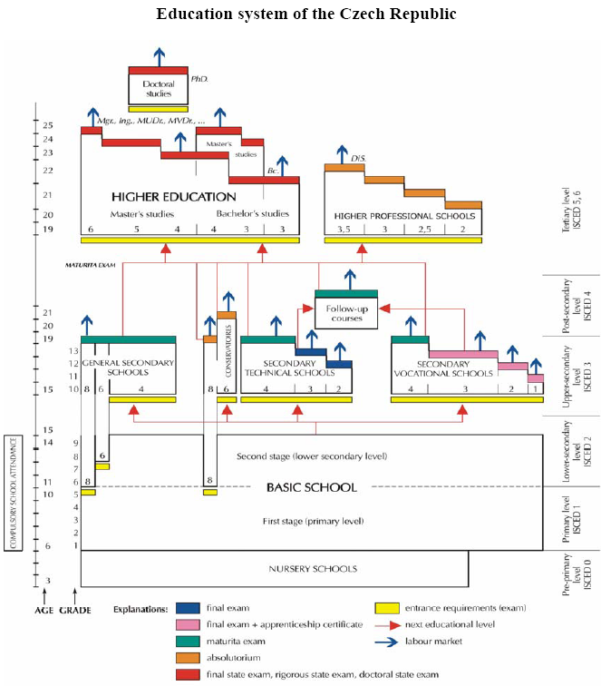
for performing arts must take a talent examination which is
a part of the admission procedure. Students after completing grade 9 of basic school can be admitted in a six-year music and dramatic art course. Students gifted in dance can be admitted in an an eight-year dance course after the completion of grade 5 of basic school. These students finish compulsory school attendance in lower grades of conservatories. Conservatory students can also take an optional Maturita examination. Six or eight- year courses are competed by passing the absolutorium. The document certifying achievement of this type of education is the Absolutorium Report and the Diploma. Conservatory graduates are awarded a degree “diplomovaný specialista” (a qualified specialist) stated after his/her name and abbreviated as “DiS”.
University study
A prevailing form of tertiary education in the Czech Republic is university study. It provides both general and vocational education. A bachelor’s degree program lasts 3-4 years (ISCED 5B). A master’s degree program focuses on theoretical knowledge based on current scientific knowledge, research and development, mastering its application and the development of creativity. In the field of arts, the program aims at arts training and talent development. A master’s degree program follows a bachelor’s degree program. The length of study is 1-3 years (ISCED 5A). In those fields, where the nature of study program so requires, a master’s degree program can be accredited without following a bachelor’s degree program. A doctor’s degree program can follow a completed master’s degree program. It focuses on scientific research, independent creative activity in the field of development or the promotion of independent theoretical and creative activity in arts. The standard length of training is 3 years (ISCVED 6) A minimum prerequisite for university enrolment is the completion of full secondary education ending with the Maturita or the absolutorium at a tertiary technical school or conservatory. Access to a master’s degree program following a bachelor’s degree program is conditional on graduating from a bachelor’s degree program; access to a doctor’s degree programme is conditional on graduating from a master’s degree program. Higher education institutions (if need be the institutions which want to provide a study program (bachelor’s, master’s or doctor’s degree program having full-time, distance or combined study forms) develop a study program and submit it for accreditation. An educational program is subject to the granting of accreditation by the Ministry of Education, Youth and Sports (MŠMT). The accreditation is based on the opinion of the Accreditation Committee established by the government of the Czech Republic. A bachelor’s degree program is competed with the state final examination and bachelor thesis defence and leads to the academic degree of “Bakalář”- Bachelor (Bc.) or “Bakalář Umění“ Bachelor of Arts (BcA). A master’s degree program is completed by the state final examination and master thesis defence. Master’s degree program graduates receive the academic degree of “Magister” - Master (Mgr.) and “Magister Umění” - Master of Arts (MgA.); “Inženýr (Ing.)”- Engineer; “Inženýr Architect (Ing.arch.)”- Engineer Architect; “Doktor Mediciny (MUDr.)” – Doctor of Medicine; “Doktor Veterinární Medicíny (MVDr.)”- Doctor of Veterinary Medicine. The holder of the Master degree can take a further state rigorous examination (“rigoózní zkouška”), which includes the defence of a rigorous thesis (“rigorózní práce”). Successful candidates are awarded the following degrees: JUDr. (in the field of law), PhDr. (in the field of humanities, pedagogy and social science), RNDr. (in the field of natural science) PharmDr. (in the field of pharmacy),etc. Doctoral study programs are completed by the state doctoral examination and doctoral thesis defence. Successful candidates are awarded the academic degree Ph.D.

